The Maze READ ME

Overview

The maze is a simply Choose-Your-Adventure game that will ask the player to pick one of two choices that will determine what will happen next. The goal is to exit the maze. The player can choose minimal combat ability or hiding capability. Your choice will determine which encounters you can overcome. You’ll have to choose wisely to get out.

WireFrame
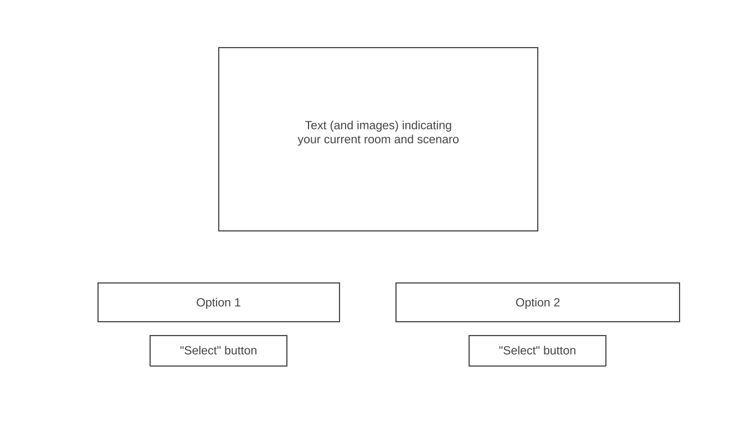
User Stories

The player will be prompted with the maze welcome screen explaining how to proceed. At the entrance of the maze, the user will have the following choices: A dagger or camouflage cloak.

Starting Items: :
- Dagger:
  - Capable of defeating smaller enemies
- Camouflage:
  - Capable of slipping pasted unbeatable enemies.

From here, the user will need to choose a starting path from 2 options. Each option will determine the next 2 encounters.

The encounters include:
- Small Enemies: Will normally include enemies that can be beaten with the dagger. (Slimes, wolves, etc.) and be bypassed with the cloak.
- Mobile enemies: Will only be passable with the dagger by defeating them. Players using the cloak will be spotted and the game will end.
- Large Stationary Enemies: Will only be passable with the cloak by sneaking through. Players using the dagger will not able to defeat the enemy and the game will end.
Once all encounters are cleared the player will exit the maze and the game will end.

Technologies

The following technologies will be used to create the maze game:
- javascript
- CSS
- HTML

